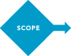
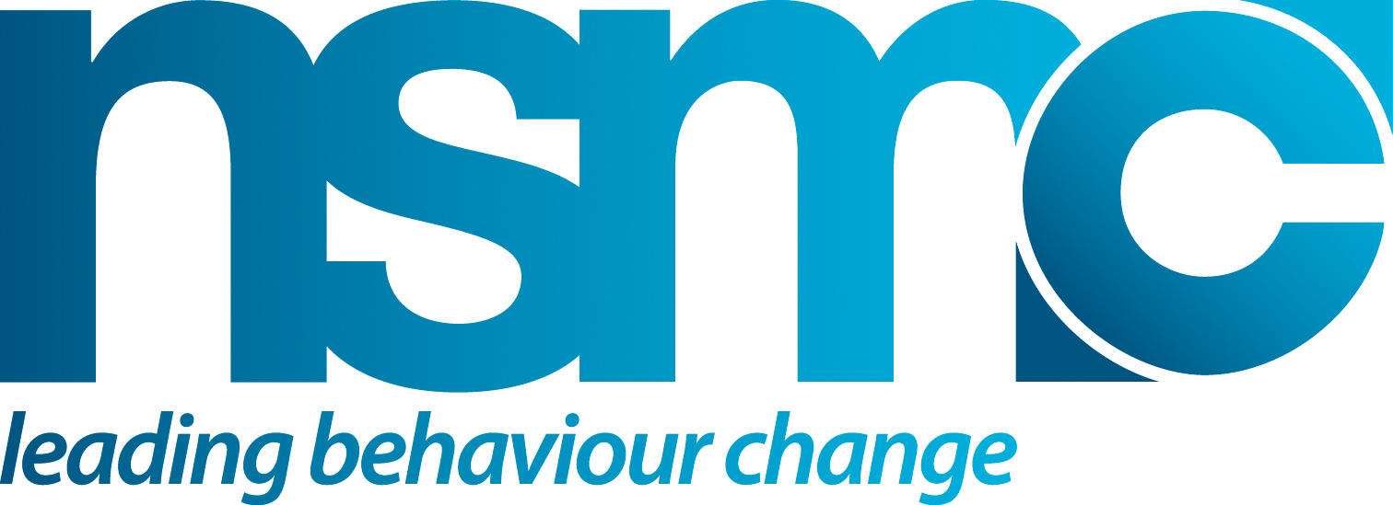

LEARNING FROM PREVIOUS INTERVENTIONS

Purpose
To help ensure that when you review past or existing interventions you identify and capture key learning’s both what went well and what didn’t work and why?

How to use or apply
Use the checklist and table to capture learnings.

Source(s)/Reference(s)
- www.thensmc.com

QUESTIONS
- What was/is the purpose of the intervention, who does it target?
- What was/is the geographical coverage?
- What was/is the timeframe?
- What was the budget
- What are the key customer understanding and insights?
- What went/worked well?
- What didn’t work well?
- How was it evaluated?
- What was the outcome and impact?
- What would you do or apply differently?

Use table set out on the next page to capture the findings

Previous Intervention | Geographical cover | Time period | Budget | Audience understanding and key insights | Evaluation methods | Outcomes/Impact | Key learnings
Title and brief description | National, regional, local etc. |  |  |  |  |  | What went/worked well?  What didn’t work well?

