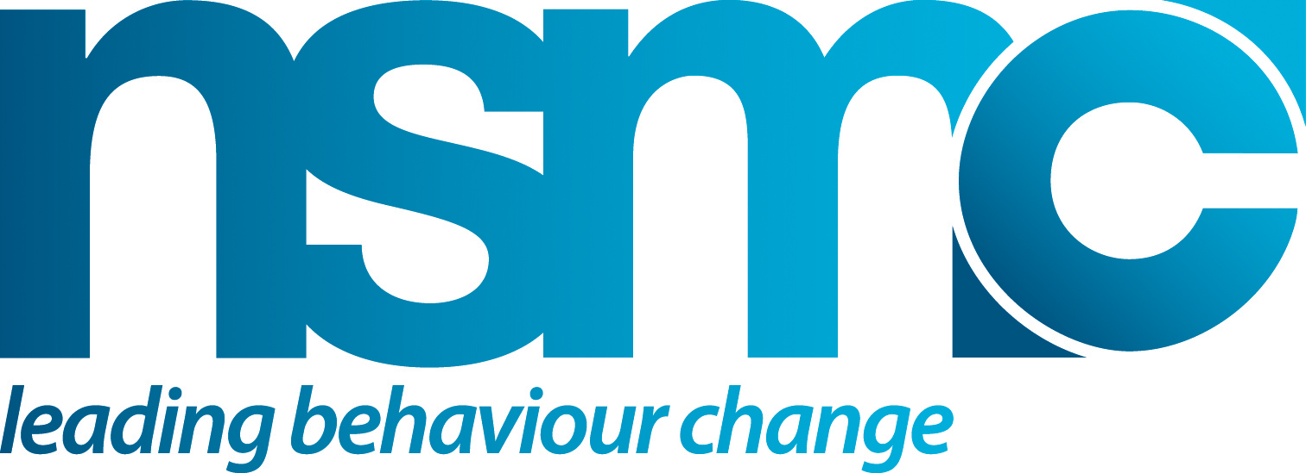



INTERVENTION MIX DEVELOPMENT

Purpose
This tool will help you pull together a mix of methods from the five primary domains of influence (Inform, Educate, Design, Service and Control) to help deliver sustainable solutions for our target audience(s).

How to use or apply
Pick up from where you reached at the end of the scoping phase and review your plans with your team and key stakeholders in light of the development work to date. Use the intervention mix to consider what specifically will be done within each of the five spheres of influence to support your intervention.

As you did in scoping, assess the potential impact of each proposed element of your intervention mix on the target audience. For example:
- How will this impact on the costs of the desired and problem behaviours, e.g. in terms of money, inconvenience, risk, opinions of others, self-perception etc?
- How will this impact on the benefits of the desired and problem behaviour, e.g. in terms of financial savings, lifestyle, opinions of others, self-perception etc?
- How will this strengthen/enhance any existing incentives for the desired behaviour?
- How will this reduce/remove any incentives for the problem behaviour?
- How will this strengthen/enhance any barriers or blocks to the problem behaviour?
- How will this reduce/remove any barriers or blocks to the desired behaviour?

Continue to ask yourself if the intervention mix is ethically acceptable.
- Does the intervention mix meet normal ethical standards?
- Will people be hurt of damaged by the intervention?
- Are you being entirely truthful?
- Are you inadvertently perpetuation inappropriate or harmful stereotypes?

Remember to stay focused on how to increase the target market’s perception of value.

The intervention and marketing mix elements have to be integrated with each other, e.g. they should be consistent with respect to key messages.

Do a final check that the target audience will be receiving a coherent and consistent message from all elements of the intervention and marketing mix.

Double check you will be acting ethically.

Source(s)/Reference(s)
- www.thensmc.com
Inform
How and what can we do to inform, advise, build awareness of, encourage, persuade & inspire?

Educate
How and what can we do to improve knowledge, understanding and skills – empower?

Design
How and what can we do to shape the environmental & physical context - design, engineer, increase availability/distribution?

Support
How and what can we do to provide support – services that support & respond ‘give people what they need, want, or value’?

Control
How and what restraints can we use - legislate, regulate, enforce, police, require,
set standards?

