Increasing child restraint use in motor vehicles
Topic:
Road safety
Organisation:
Injury Prevention Center of Greater Dallas (IPC)
Location:
Dallas, Texas (USA)
Dates:
1997 to 2000
Website:
www.injurypreventioncenter.org
Contact:
Greg Istre (Epidemiologist and Medical Director)
Email:
greg.istre@phhs.org
Telephone:
001-214-590-4464

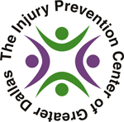



Overview
This community-based, culturally integrated programme aimed to increase the use of child safety restraints in a Hispanic neighbourhood in the west Dallas area of Texas. Funded in part by the National Highway Traffic Safety Administration, the National Center for Injury Prevention and Control and the Centers for Disease Control and Prevention, the ultimate aim was to reduce the number of child injuries and fatalities occurring due to the lack of use of car seats and booster seats.

This multifaceted three-year programme incorporated a series of education and engagement activities conducted in the target area by trained bilingual staff, most of whom were residents of the local neighbourhood. Parents who attended the informational sessions were also offered subsidised car seats, which had been blessed by a local priest.

The programme was found to be most successful among parents who attended the community health centre, which was the main site of intervention activities, and in the preschool age group (children younger than five years). Based on structured observational surveys, use of safety restraints among Hispanic preschool-aged children increased from a baseline of 21 per cent to 73 per cent three years after the programme launch.

Child passenger motor vehicle crashes are the leading cause of death for children aged 1 to 14. However, many of these deaths and injuries associated with motor vehicle crashes can be prevented by using proper child passenger safety restraints, such as car seats and booster seats. According to the National Highway Transportation Administration (NHTSA):

- Approximately three out of four car seats are incorrectly installed
- Correct use of car seats reduces fatal injury of infants by 71 per cent and of children aged one to four years by 54 per cent
- Booster seats reduce injury risk by 59 per cent compared to seat belts alone

Child safety seats (CSSs) not only save lives, but they also save money: every US$46 spent on a CSS saves the government US$1,900 in societal costs and every US$31 spent on a booster seat saves US$2,200.

All states in the US have child restraint laws that require child safety seats for infants and children that fit specific criteria. Texas law requires all children under the age of eight to be properly restrained in a CSS, unless the child is taller than four feet, nine inches. First offence fines for not complying with the state’s child passenger safety laws can be up to US$200.

In 1992, to address the issue of increasing rates of injuries and trauma-related deaths in Dallas, more than 100 area health, government and business leaders developed and established the Injury Prevention Center of Greater Dallas (IPC).

One of the problem areas the IPC targeted in 1997 was the (lack of) use of CSS to prevent death and injury. A series of academic reviews in the US found the use of safety restraints in motor vehicles to be less common in minority and low-income populations than in the general population. Furthermore, analysis of existing Texas Department of Transportation research indicated that populations of new immigrants, including those residing in areas of west Dallas, were at high risk of traffic crashes. This was due to a variety of factors, such as language barriers, traffic signage, speeding, alcohol use and seat belt non-use. Analysis of Texas state data, including emergency response, police and hospital data, found that a disproportionate percentage of car accidents involved those of Hispanic origin.

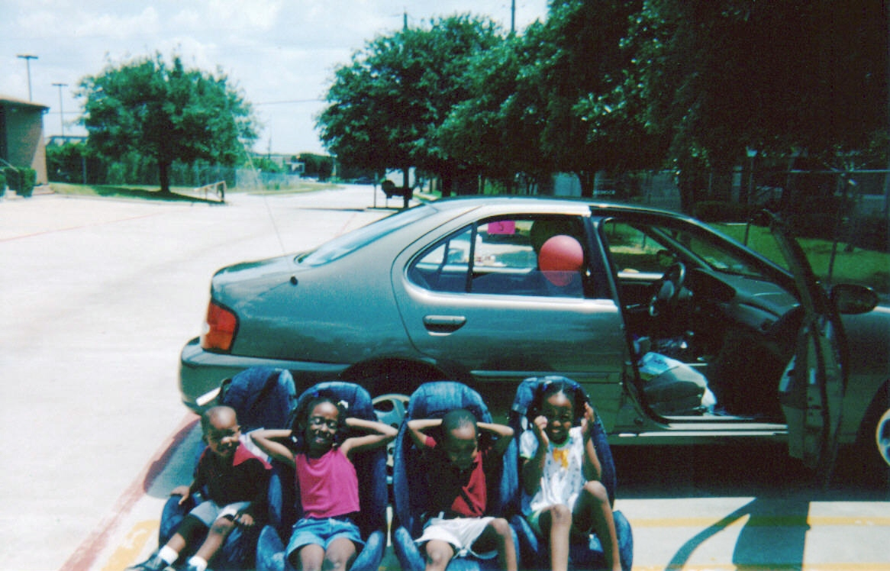

Texas has one of the largest populations of citizens of Hispanic origin in the US and is home to over 8.6 million Hispanic citizens, who make up 36 per cent of the state’s population. Dallas has a large Hispanic population, which makes up 43.1 per cent of the city’s total population. A preliminary survey of Hispanic preschool children in west Dallas, carried out in 1997, showed much lower child restraint use (19 per cent of those surveyed) than among preschool children of all races in the rest of the city (62 per cent).

In response to this discrepancy, the IPC developed a programme in 1997, with the support of local Hispanic community organisations, to increase use of CSS amongst Hispanic groups living in west Dallas. The ultimate goal was to reduce the number of child injuries and fatalities occurring due to the lack of use of child safety restraints.

The programme was funded through a three-year grant from the NHTSA, who wanted to concept test the Safe Communities Model, and the National Center for Injury Prevention and Control, part of the Center for Disease Control and Prevention (CDC), who wanted to reduce the number of fatalities due to lack of seat belt use.

A team of the staff from the IPC was set up to lead the programme, including the Director, Director of Research and Director of Community. They were supported by a core group of injury prevention experts who met to review the work once or twice a year.



Target audience
Three adjacent zip codes in the west sector of Dallas were chosen as the target areas because of their predominately Hispanic population, which totalled 110,000 and constituted 60 per cent of the area’s population. Preliminary observational surveys had shown that among Hispanic preschool-aged children child restraint use was lower than 20 per cent in several settings in these zip codes. This was compared to 62 per cent child restraint use in the rest of Dallas and around 60 per cent use in the state of Texas.

Parents, in particular mothers of young children, within these Hispanic communities were targeted because they tended to be responsible for supervising their children and were seen as authority figures within the community.
Audience research
To explore why CSS use was so low amongst the target audience, the IPC facilitated 6 focus groups, each ranging in size from 7 to 14 participants recruited from community groups and who lived in the area. The IPC also conducted interviews with professionals working in the community. These were held during the first three months of the programme to inform the design of the interventions.

Along with the study of best practice, the knowledge gained in these focus groups helped identify what kinds of interventions would and would not work with this target audience. For example, the IPC had originally planned to implement a popular incentivised reward scheme designed in North Carolina, whereby drivers observed using a car seat correctly would be stopped and given a prize or coupon. This idea was rejected in the focus groups – participants advised that residents would just use the seats long enough to get the reward and would not consistently use it. The IPC also considered recruiting celebrities to champion the importance of car seats. Again, this idea was dismissed by the focus group participants, who emphasised that mothers are the most trusted members in the Hispanic community and would have much better and wider influence across the community.

Barriers and competition
Focus group discussions revealed a number of key barriers to increasing car seat use amongst the target audience:
- There was a lack of information on child restraint laws, the importance of using car seats and how to properly install and use them. This was especially true for families who had recently immigrated to the US, as regulations were often different in their native countries.
- Language barriers prevented some parents from being able to read and understand existing child car safety literature. Target audience members were more inclined to watch television or listen to the radio, rather than read. Research participants emphasised the need to educate parents face-to-face in small classes.
- Car seats were considered too expensive and their bulky designs meant they took up too much space in the vehicle and were inconvenient to transfer from vehicle to vehicle.

A number of factors also competed with the project’s goal of increasing car seat use:

- Religion plays a prominent part in Hispanic culture. Fatalistic views and the belief that any potential accidents were ‘in God’s hands’ were key internal competitors to getting parents to use child safety seats. This led parents to believe that using car seats would have very little impact on changing their destiny. Some even believed that by using car seats they would be interfering with the will of God.
- Even amongst those who were aware of the child restraint laws, many parents did not see the value of using car safety seats and felt that their child was safest in their arms. Parents also tended to believe they were safe drivers and therefore less likely to be in an accident, particularly when making ‘short’ trips. Lack of enforcement of child restraint use only contributed to parents dismissing the use of CSSs.
- Target audience members were much more concerned about reducing the levels of violence and crime within their community, than increasing road safety. It was therefore tricky to engage this group in a low priority issue that they were disinterested or apathetic towards. This was not helped by an inherent lack of trust of outsiders entering their community and asking for their views.
- Mothers faced resistance from their children and male partners or family members, who tended to view seat belts as undermining their masculinity and were therefore less likely to see the value of CSSs.

Since CSS use was not part of the tradition or culture of the target community, the programme team developed an approach that worked with community members and incorporated various aspects of Hispanic culture to promote the use of CSS.

To identify key stakeholders, the team mapped the assets of the community. They then created a ‘hit list’ of the kinds of stakeholders they wanted to engage with and asked them to participate in the programme. They were quite surprised at how positively the stakeholders responded: people knew this problem existed but did not know what to do to address it. The team used targeted strategies for buy-in from each group but essentially requested the same support which was simply asking them to use their specific resources to communicate the need for child safety seats.

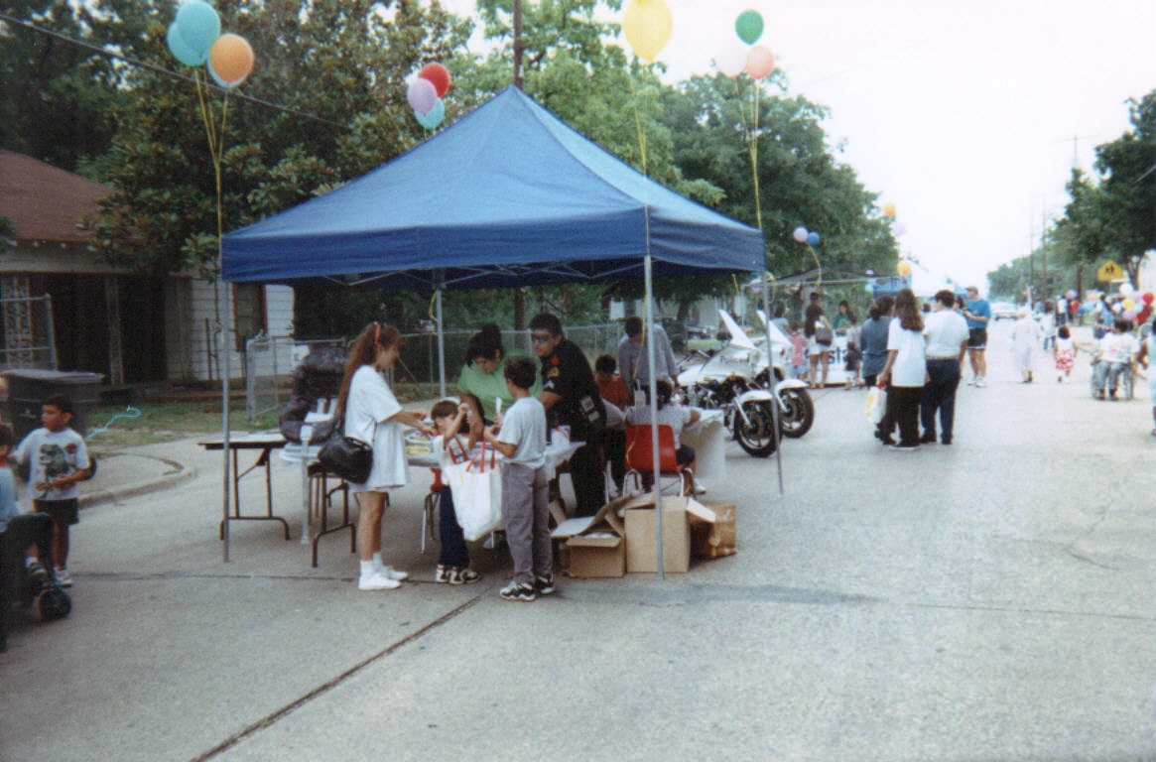

Using the World Health Organization’s (WHO) Safe Communities model, the team developed a multifaceted programme to educate, encourage and enable target audience members to correctly use CSSs. The model uses a ‘bottom up’ approach and is developed from standardised educational programmes. It has four distinguishing features:

- Injury data analysis from multiple sources of data
- Expanded partnerships
- Resident involvement
- An integrated and comprehensive injury control system

The benefit promised to parents of using CSSs was the ensured safety of their child when travelling in the car and, by extension, the reduced risk of child fatality and injury. A number of interventions were designed and adapted to the Hispanic community using the insights gained from the focus groups. Interventions would be delivered throughout community venues and by trained bilingual staff, preferably those who were also residents of the target area.

Child safety seat training and traffic safety workshops
As lack of knowledge and information were key barriers to increasing use of CSSs, classes would be offered free to the target audience and delivered by certified child passenger safety technicians, who would stress the importance of using CSSs during all car trips, regardless of length of travel.

The use of shock tactics was recommended by the focus group participants for getting the message across, which was surprising given that research with other ethnic groups found the use of drama and gore off-putting. Videos that graphically showed what happens to a child held on an adult’s lap during a car crash were therefore created to be shown in the classes. The classes would also include seat belt demonstrations and provide parents with tips on what to do when their child refused to sit in the safety seats.

In addition to CSS training, IPC staff would run workshops at day care centres and throughout the target neighbourhoods about vehicle safety, driving licenses, traffic laws and how to properly install and use CSSs. To increase the relevance of these workshops, other issues considered important by the target group would also be covered, such as immigration and social security.

Subsidised car seat purchase scheme
As an additional incentive, parents who attended the classes would be offered a car seat for a low cost of US$10. This was made possible by working with members of the Texas Department of Health’s Safe Riders programme and the Texas Department of Transportation, which provided a grant to subsidise the car seats. To overcome the issue of fatalism in the Hispanic community, local priests would be asked to bless the child safety seats in a ceremony before they were given to parents.

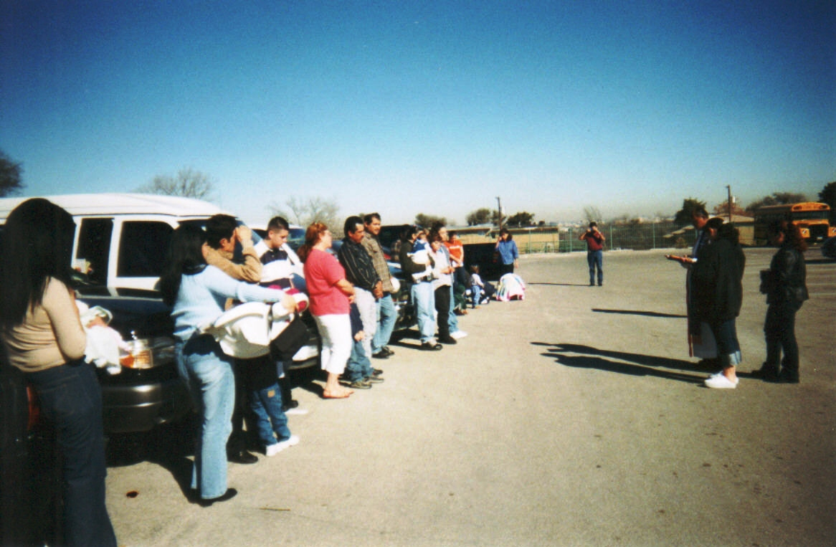

Community engagement activities and community liaisons
Information and engagement activities would be provided at various community venues, such as schools, churches, community centres and local botanicas (traditional healers). Other key influencers, such as healthcare professionals and the police, would be enlisted to help engage with the target audience.

Since mothers were seen as authority figures within the Hispanic community, a group of local mothers would be recruited to help develop an ongoing relationship with the day care centres and implement interventions tailored to the centres’ needs and interests.

Communication materials
Effective and accurate communication was an essential element of the methods mix. Key messages were developed to be clear, simple and meaningful. It was crucial that these were consistent across all locations and channels of distribution. The key messages to convey were:

- Child safety seats are important and they save lives
- Children are not safer in their parents’ arms or on their lap when travelling
- Car safety seats must be used for all journeys, regardless of the length of the trip

All activities and information would need to be in Spanish and English to overcome any language barriers. To reach as many of the target audience as possible, the messages would be conveyed through various media. The team had originally planned to advertise the interventions in the local paper. Following feedback from the focus groups that the target audience preferred to listen to the radio instead of read newspapers, advertisements were developed for the radio instead.

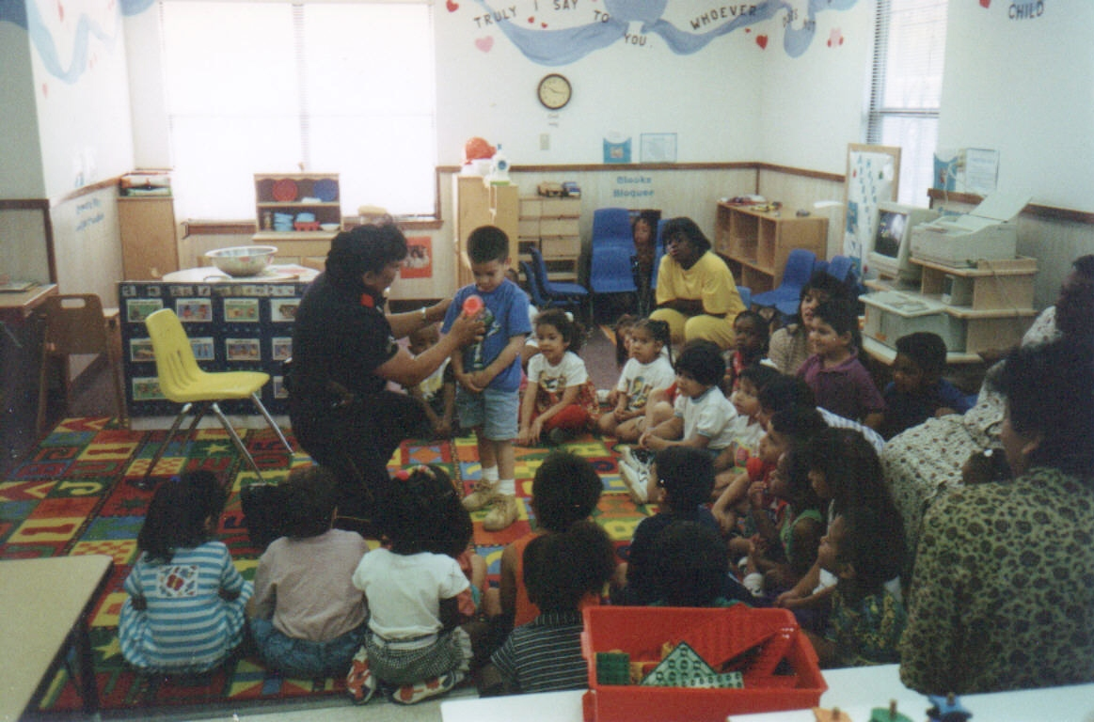

To help carry out the programme, the IPC engaged with various local, state and national groups, such as the Dallas Police Department and Texas Department of Transportation. To reach the Hispanic community, the team also worked with community organisations, including the deHaro Saldivar Health Center, day care centres and the Avance Dallas and Wesley-Rankin Community Center.

Indicators and baselines
Since the IPC did not have access to morbidity data and the number of deaths due to lack of CSS use was too small to prove a significant change, observations of child restraint use was used as the main indicator of the programme’s impact. Baseline data was collected before the interventions started. Beginning in February 1997, surveys were conducted as vehicles entered parking lots at three types of locations in the target area. To provide comparison data, surveys were also carried out at day care centres and shopping centres in other parts of the city.

The interventions were delivered between 1997 and 2000 in three key settings in the target area: the county-sponsored primary care health centre (the deHaro Saldivar Health Center), day care centres and community venues. The CSS classes were initially held at the clinic, childcare centres, schools and community centres, but after a year and a half the team realised they were getting the most participation at the health centre and therefore scaled back the classes at the other locations.

Health centre
Hour-long bilingual training classes on the proper use and installation of CSSs were held in the target area throughout the programme, beginning in May 1997. Classes were held biweekly at the community primary care health centre, as well as at other locations in the community on request. Classes were advertised through the local health clinic, churches, community centres and botanicas, and on local Spanish-language radio and television shows. Physicians, nurses and staff at the centre helped maintain the sign-up lists for classes. More than 3000 CSSs were distributed to Hispanic families in the target area during the survey period.

Class instructors participated in health fairs and special events sponsored by the health centre – as well as distributing pamphlets, they conducted CSS inspections and demonstrations.

Paediatricians at the health centre reinforced the importance of using CSSs by distributing ‘prescriptions’ for proper CSS use to patients. These were prescription pads that had been pre-printed with instructions for parents to get a car seat for their child, and a phone number they could call to sign up for a class.

Day care centres
A week-long intervention was held for children, parents and day care staff, which included seat belt demonstrations, colouring contests, CSS training for day care centre employees and traffic safety workshops for parents. It emphasised the importance of seat belt use by parents, as well as use of CSSs.

Three local mothers were hired as liaisons to promote child safety seat use over a nine-week period in five day care centres. They held a number of activities, including information booths, raffles and games, all designed to promote CSS use.

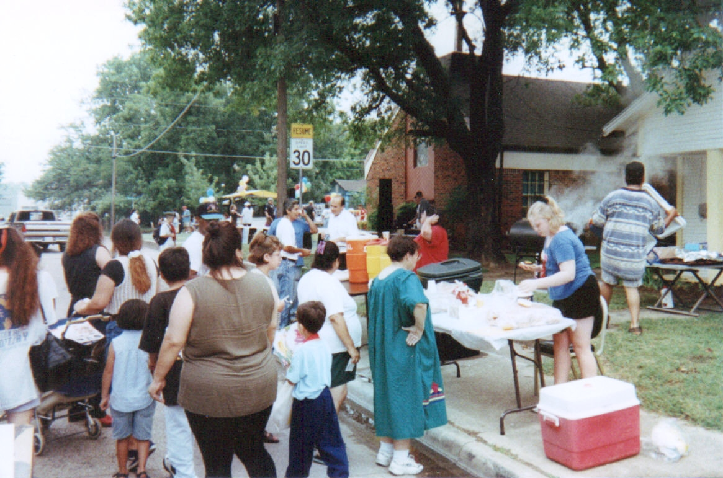

Neighbourhoods
Interventions were implemented in several neighbourhoods in the target area, including neighbourhood block parties, health fairs, CSS inspections, traffic safety workshops and delivery of educational messages at local festivals. Many of the activities also provided information on other issues important to the target group, such as home safety, domestic violence, child abuse and other community resources.

At local schools, churches, and neighbourhood events, a Hispanic policewoman known as La Protectora (‘The Protector’) held classes in Spanish and English for parents and children to explain child safety laws and procedures. Her role of La Protectora was funded by a grant from the Texas Department of Transportation to the Dallas Police Department.

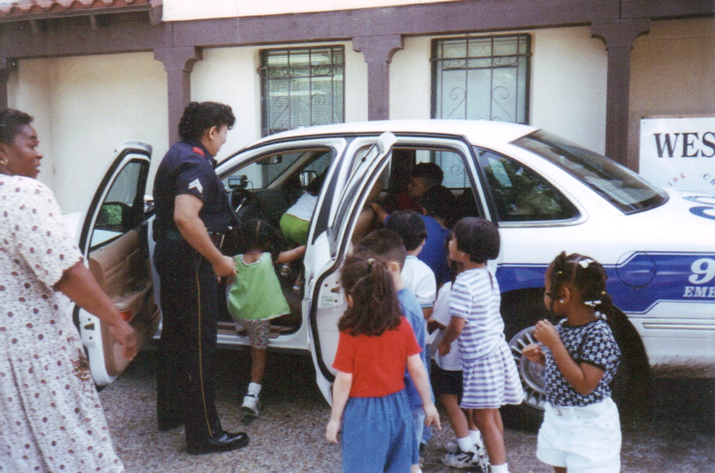

Educational pamphlets on CSS and seat belt use were distributed through local botanicas, churches, and community centres.

Despite basing the interventions on insight gained from the focus groups, the team faced a number of barriers during the implementation stage. For example, there was little initial uptake of the car safety seat classes. The target audience saw car seats as unnecessary and expressed little interest in using them. Some members of the community had reportedly already been given car seats, but chose not to use them. With low income and poverty being an issue for many in the community, one family had reportedly kept their car seat in their living room still unused in its wrapping because it was the nicest thing they owned.

To overcome these barriers, the team persevered in promoting the interventions and the importance of CSSs. Members who had come from and/or worked within the target community before (such as the Project Lead for community involvement) and who were more readily accepted and trusted by the target audience were enlisted to support the programme. Given the low priority placed by the target audience on CSS use, the team made sure to provide a valued exchange by tying their interventions in with other offers, such as exercise classes for women and a presentation on how to deal with violence.

Response to radio advertising was also disappointingly poor, so the team approached the local Spanish-speaking television station to promote the interventions, which led to a much more positive response. However, the best communication channel was word-of-mouth from mothers and through churches, schools and day care centres.

The IPC Director monitored the programme to insure work was progressing and on track to meet its objectives. Regular collection of surveillance data helped the team understand which aspects of the programme had the most and least effect. For example, the team had initially planned a lot more community fiestas, but found they took a lot of time and produced little return. Instead, the child safety classes with the distribution of seats were by far the most successful, and the graphic video footage had the biggest impact. However, the multifaceted approach made it tricky to assess the impact of individual interventions, compared to the combined effect of several activities.

The team successfully maintained engagement with stakeholders throughout implementation by sharing data on a regular basis, thereby allowing them to see the progress being made and sustaining their motivation. Stakeholders also met regularly to review progress, discuss any difficulties and make any necessary adjustments. Luckily the funders were willing to adjust how the programme funds were spent according to how the interventions were doing.

Child restraint surveys were performed by trained observers, using forms developed by the Texas Transportation Institute (TTI) and used for the past 13 years for longitudinal studies of restraint throughout Texas. The National Center for Injury Prevention led on the evaluation aspect of the project and were all trained observers in the TTI observational method.

Beginning in February 1997, surveys were conducted as vehicles entered parking lots at three types of locations in the target area:

- The community health centre where the interventions was implemented
- Day care centres that also received the interventions
- The parking lots of eight grocery stores, which were patronised predominately by
- Hispanics

The comparison area sites were day care centres and shopping centres in other parts of the city.

Observations at the grocery store parking lots were considered to be most representative of the community as a whole. Children who were restrained in accordance with Texas state law were considered properly restrained (in 1997, Texas law stated that children up to two years of age had to be in car seats, and those of three to four years had to be in either a car seat or a seat belt). The safety seats were not examined in detail to determine whether they were appropriately tightened and tethered.
A total of 7,413 observations among preschool-aged Hispanic children (under five years old) were conducted from 1997 through to 2000: 2,246 (30 per cent) of these were conducted at the health centre, 2,735 (37 per cent) at day care centres, and 2,432 (33 per cent) at grocery store parking lots. Additionally, 4,137 comparison observations were done by TTI on preschool-aged children of all races in other parts of Dallas.

The TTI survey also observed driver seat belt use at the target areas and other parts of Dallas, since driver seat belt use was believed to be a necessary factor in child restraint use (although it is not the sole determinant).

Findings
Three years after the interventions were launched, the use of safety restraints among Hispanic preschool-aged children increased from an initial prevalence of 21 per cent to 73 per cent. Use of restraints among Hispanic preschool-aged children increased significantly in all three settings (health centre, day care and grocery store parking lots). By the third year of the programme, vehicle restraint use among Hispanic preschool-aged children had surpassed restraint use among preschool-aged children in the rest of Dallas (69 per cent), and by the sixth year, restraint use among clinic attendees had surpassed 85 per cent.

Other significant findings and results include:

- More than 3000 child safety seats had been distributed to Hispanic families in the target area during the survey period
- The programme was found to be most successful among parents who attended the community health centre, which was the main site of intervention activities, and in the preschool age group (children younger than five years)
- The predominant impact of the programme in the overall community (as measured by the surveys in grocery store parking lots) was seen among children younger than two years
- Observed driver seat belt use increased significantly in each of the three settings, whereas the TTI survey showed little change in driver seat belt use in other parts of Dallas
- There was a strong association between child restraint use and driver seat belt use at all of the observation sites. The association remained strong after results were stratified by year, setting, age of the child and type of vehicle

The team presented the final results to the NHTSA and to the CDC. Community stakeholders also received presentations of the final data. The team wrote up the programme and shared their findings in journals articles, presentations at national and international conferences and various websites.

The programme informed and influenced policy as it highlighted the need to address the Hispanic population, which had been largely ignored until this initiative. Following the programme, several groups started specialising in targeting this population. When grant money is available, child safety seat distribution programmes are provided in the neighbourhood. For example, a traffic safety programme for youths aged 10 to 14 has since been implemented in the same neighbourhood.

Since the programme ended, another grant was given to the IPC to try and replicate the success in a tri-ethnic community, targeting a broader age group and range of behaviours: to encourage children under 4 to use a car seat, children from 4 to 16 to use a seat belt, and children 5 to 8 to use a booster seat. The results were good with the Hispanic population, but less so with the African American or white populations. This suggested that the programme may not be as applicable to other ethnic groups and may be quite specific to the Hispanic population. However, overall the intervention did prove successful in increasing compliance with Texas state child restraint law.

Lessons learned

The programme owed its success to:

- its ongoing, multifaceted nature
- its integration of cultural and religious factors
- the use of Hispanic teachers in child safety seat classes
- the efforts of the community health centre staff in integrating safety messages into the clinical routine
- the feedback the programme team received from surveillance data about the programme’s progress

For a programme to be successful in increasing child restraint use, it must also target driver seat belt use. Only small increases in child restraint use were observed in vehicles in which drivers did not wear a seat belt. Males were also less likely to use a seat belt and child seat.

Although the team found a significant increase in child restraint use in the community (as measured by the grocery store and day care centre surveys), this remained significantly lower than use at the health centre, indicating that there is much work still to be done. Some of the increase in restraint use at the health centre may have been due to a ‘social desirability’ effect – parents going to the health centre, which was the primary site of the intervention activities, may have been more conscious about practicing car seat safety. Although the overall trend in restraint use in the rest of Dallas was relatively flat, there were some fluctuations from year to year, which may have reflected other community factors at work that influenced child restraint use.

In retrospect, the team would ideally have conducted more focus groups to gather further views and insights from the target audience to shape the interventions. It would also have brought in more staff and resources to ease the pressure of delivering against a significant grant within an ambitious timeframe. More active engagement from mothers in the community would also have helped to spread the message and enhance the impact of the project.

Acknowledgements
With special thanks to Martha Stowe (Community Lead), who contributed to the content and development of this case study.

